March 16, 2022
Ref: IIH/MD/2022/03/003

His Excellency,
The Executive Governor of Kwara State,
Government House,
Ahmadu Bello Way,
GRA, Ilorin, Kwara State

Your Excellency Sir,

RECOMMENDATION FOR EXTENSION OF FIRST FLOOR AT ICT INNOVATION HUB TO CREATE ADDITIONAL OFFICE SPACE
As the construction of the ICT Innovation Hub comes close to completion, I would like to make a recommendation of a key adjustment that will benefit the project hugely. As you’re aware Sir, the building has an open exhibition hall feel to it, with a lot of room and space that will be demarcated and partitioned into the different sections in the fit-out.

During the planning of the different sections which has been submitted to you previously, it was discovered that a key part of the building on the ground floor isn’t maximizing space efficiently. The area marked for retail shops and server room is open with no ceiling and extends all the way through the first floor to the roof. If this area could be given a ceiling (which means a corresponding floor on the first level), it will create additional space on the first level for partitioned offices and meeting rooms.

I have discussed this with the building consultant, contractor and the Ministry of Enterprise, and the consultant has submitted a quote to the Ministry of Enterprise of how much this modification will cost. The total amount in the quotation (attached) is N8,690,472 (eight million six hundred and ninety thousand four hundred and seventy-two naira) only.

Some benefits of this modification are:
- Increased capacity in the building to accommodate more offices
- Increased revenue from the offices created
- Addition of meeting rooms for entrepreneurs/startups usage
- Better privacy and security for retail shops and server room

I write to ask for your approval for this change to be considered, and the quote sent to the Ministry of Enterprise assessed and negotiated for minimal cost. This modification has been considered but not presented to you because of all the other issues on ground on the project that we have been working to resolve over the last few months.
Below are drawings highlighting the areas in question on both floors.

Ground Floor | First Floor
The areas in green are open with no ceiling and extend to the roof. | The areas in green will be newly created with introduction of a ground floor ceiling and extension of First floor.
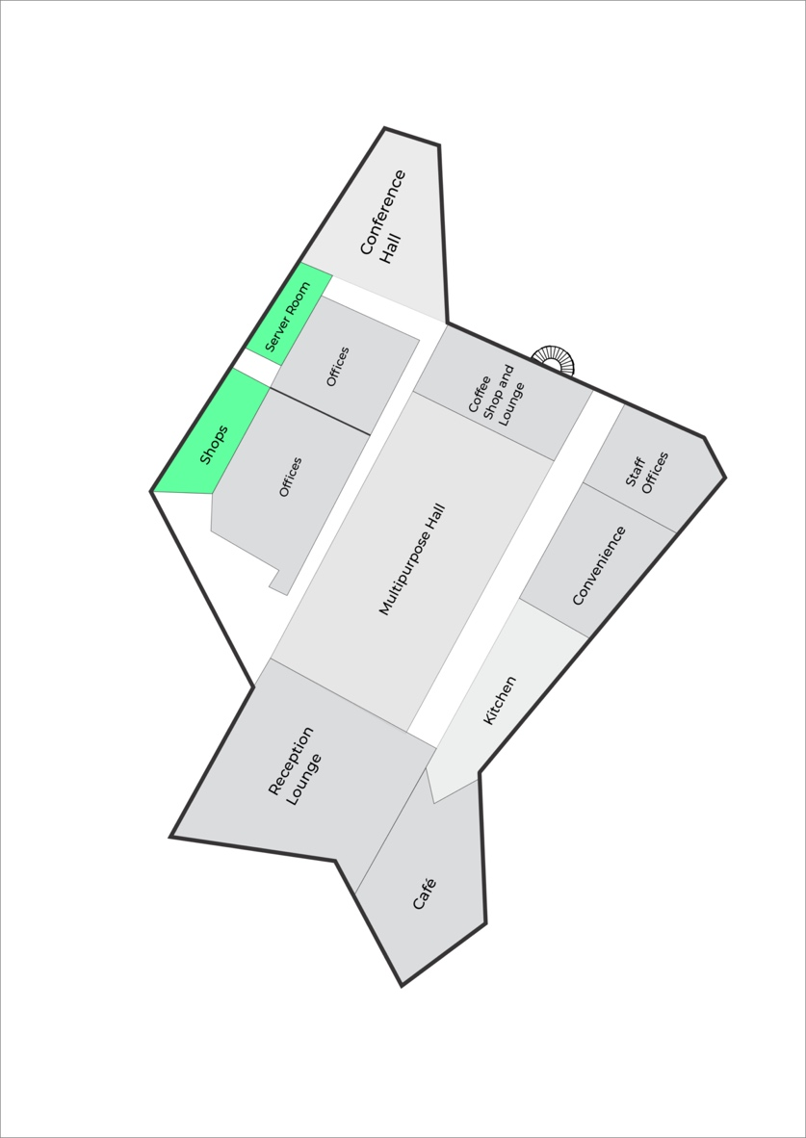 | 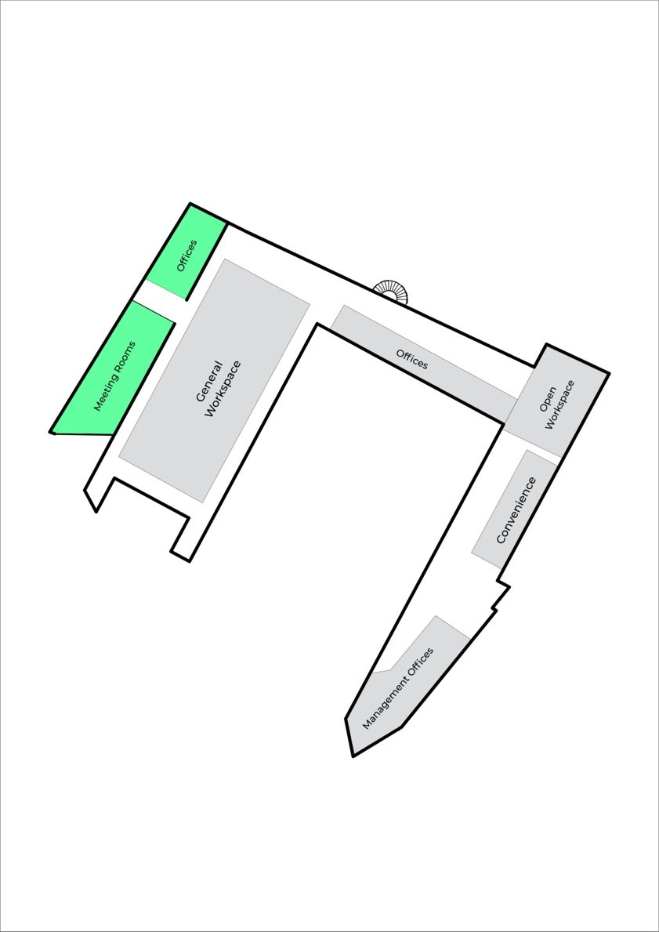


Yours sincerely,

Temi Kolawole
ag. Managing Director

